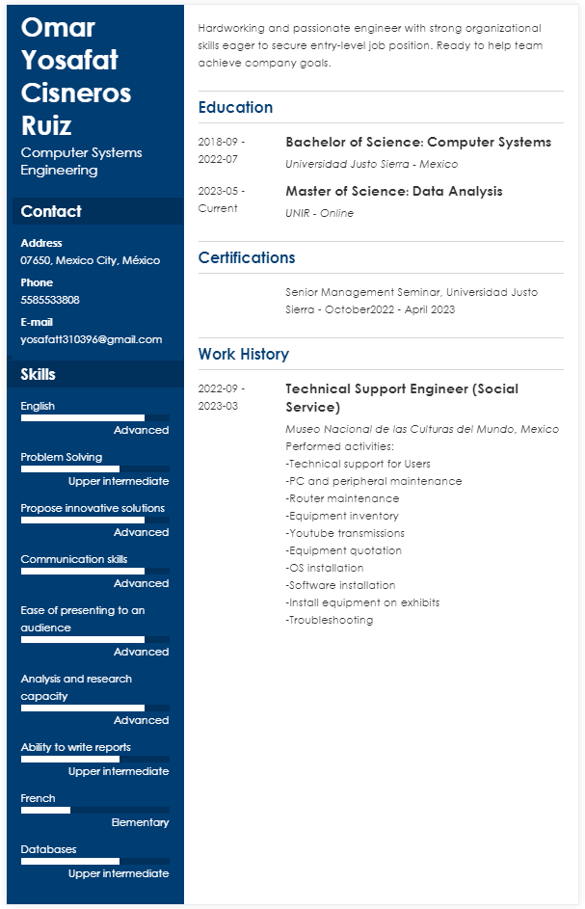Full version at: https://yosafatcisneros.github.io